NAME: Lutendo Winnie Lidzebe
STUDENT NUMBER: u23908972
DATE: 23/05/2025
BRIGHTLEARN
BUILDING A RETAIL SALES DATA AGENT

PROJECT OBJECTIVES

The goal of the project was to build a data agent on Databricks that allows business users, store managers, heads of departments, and executives to ask questions in plain language about retail sales performance and receive accurate data-backed answers without the need to write SQL code.

DATASET DESCRIPTION
Column | Type | Description
Transaction ID | Bigint/integer | Unique identifiers for sales transactions
Date | Date | Date when the transaction occurred
Customer ID | String | Unique identifier for each customer
Gender | String | Gender of each customer
Age | Bigint/integer | Age of each customer
Product Category | String | Category of product purchased
Quantity | Bigint/integer | Number of items purchased
Price per unit | Decimal/Bigint | Price per unit sold
Total Amount | Decimal/Bigint | Total value per transaction

STEPS FOLLOWED

- UPLOAD DATASET
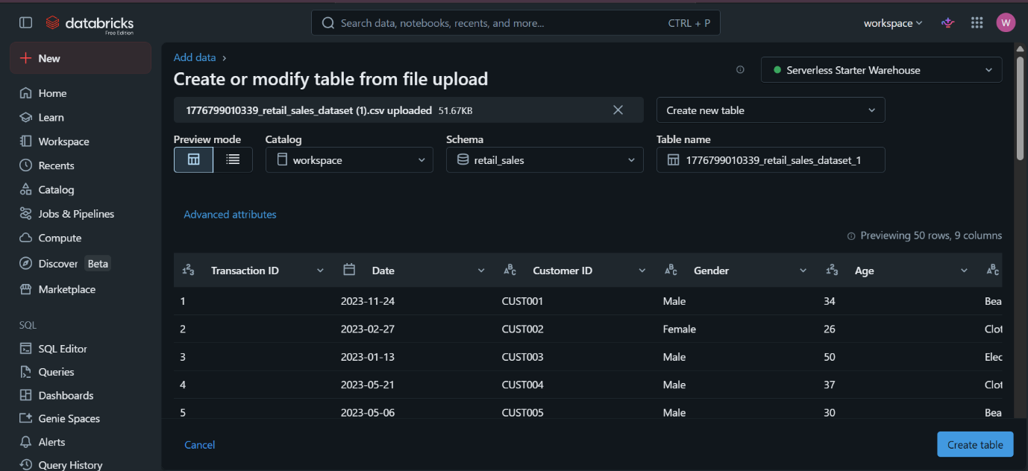

- REVIEW COLUMNS
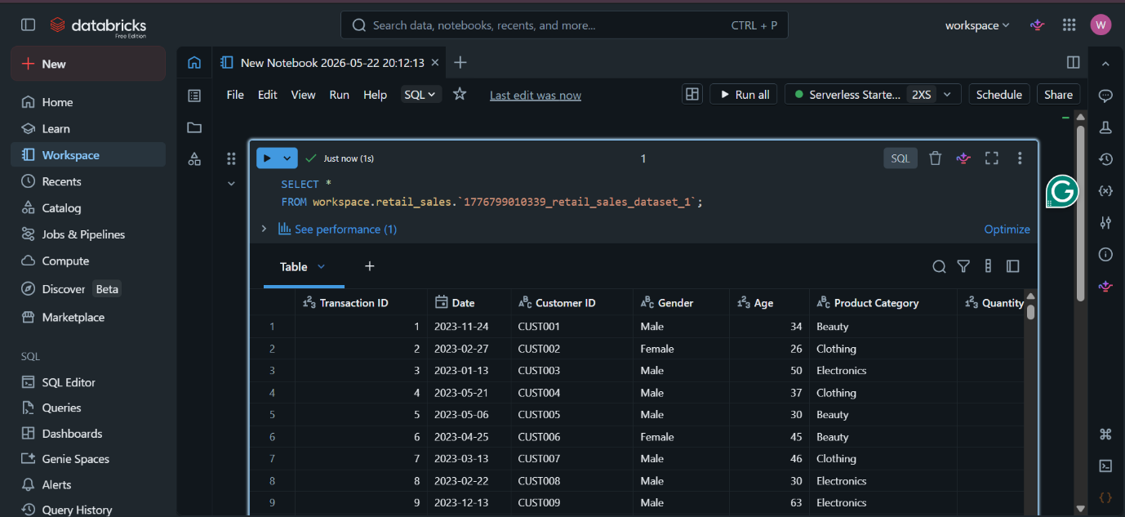
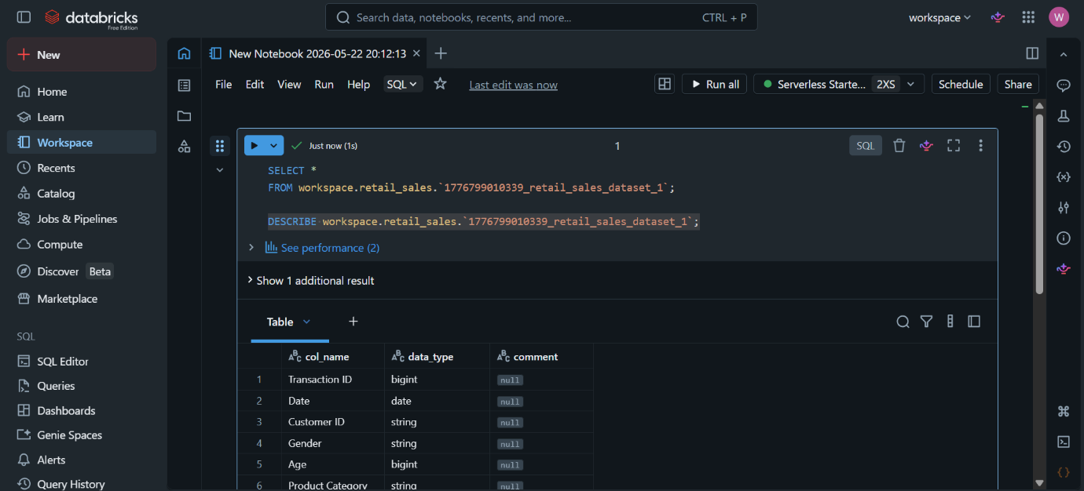

- PREPARE TABLE
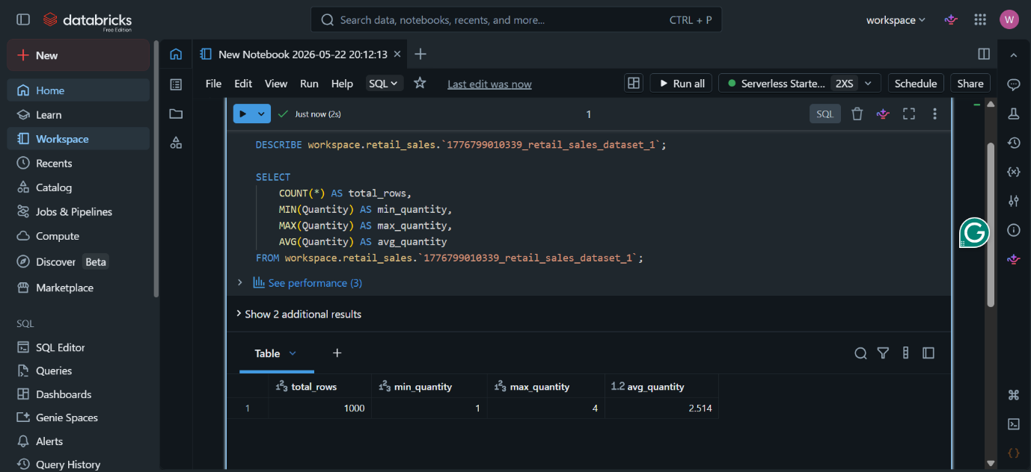
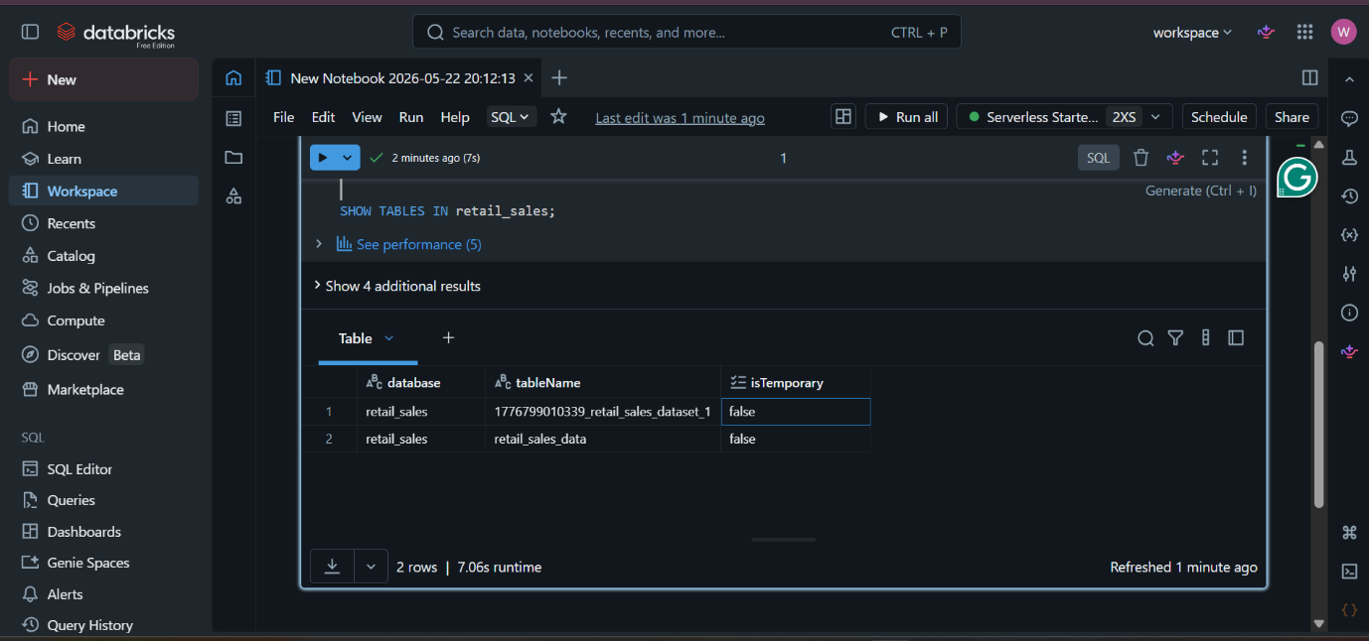
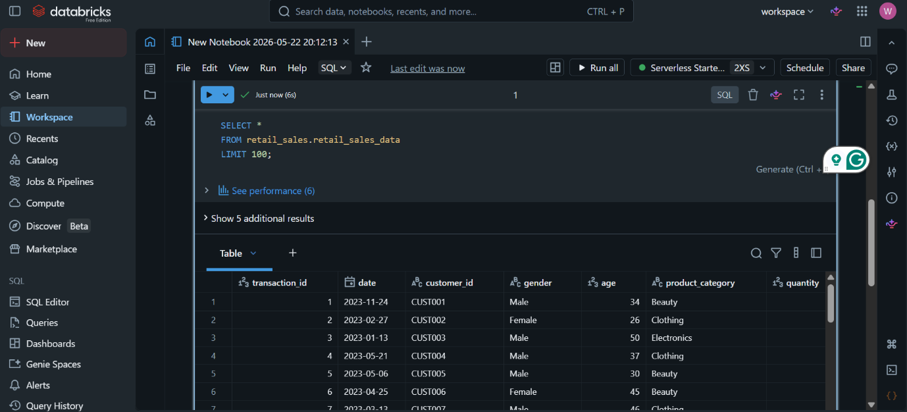

- AGENT SETUP
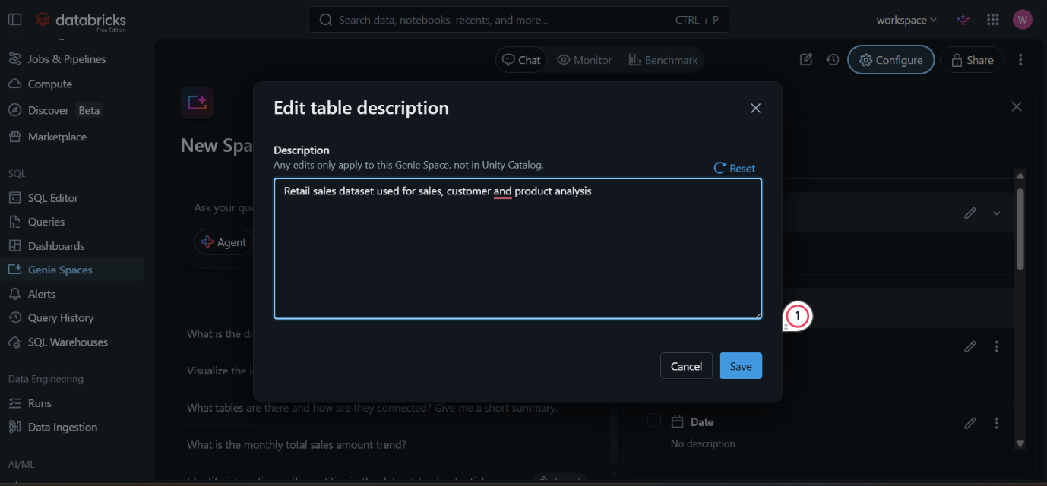

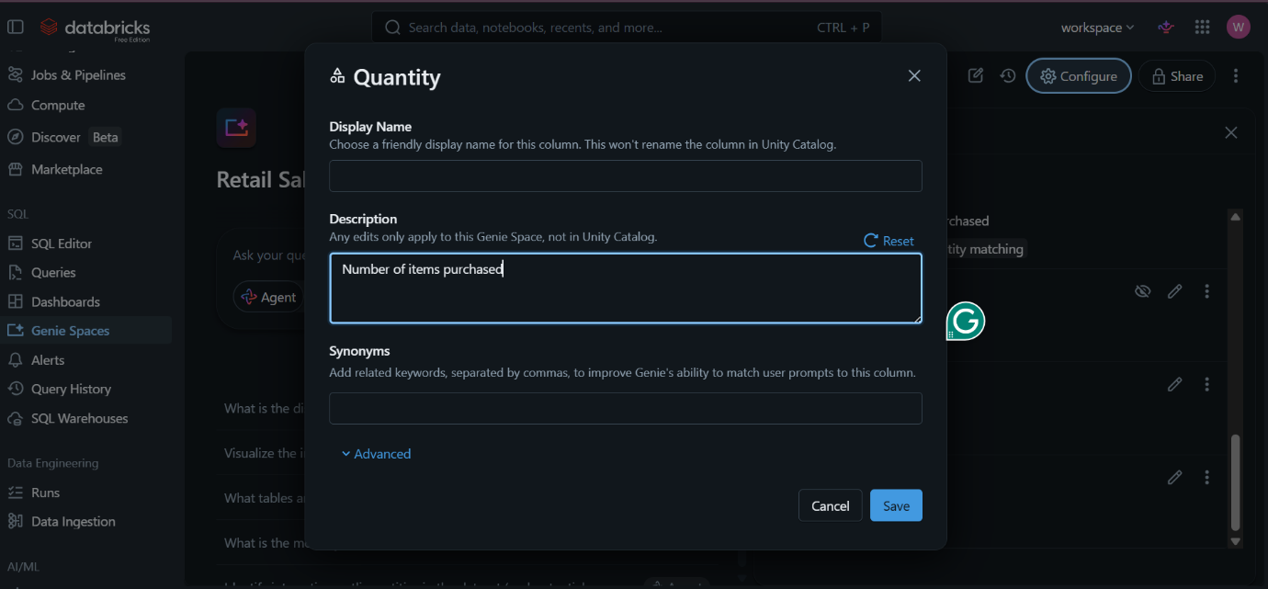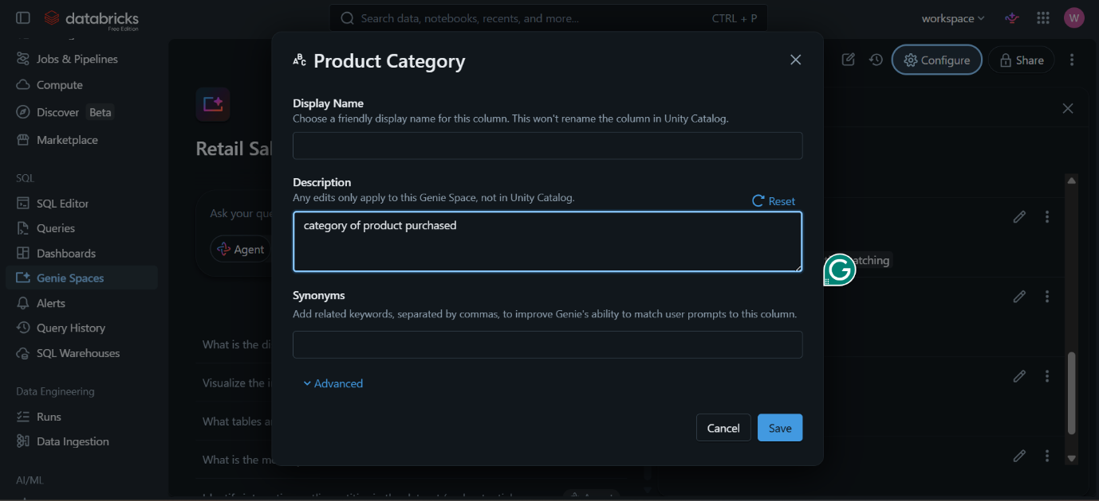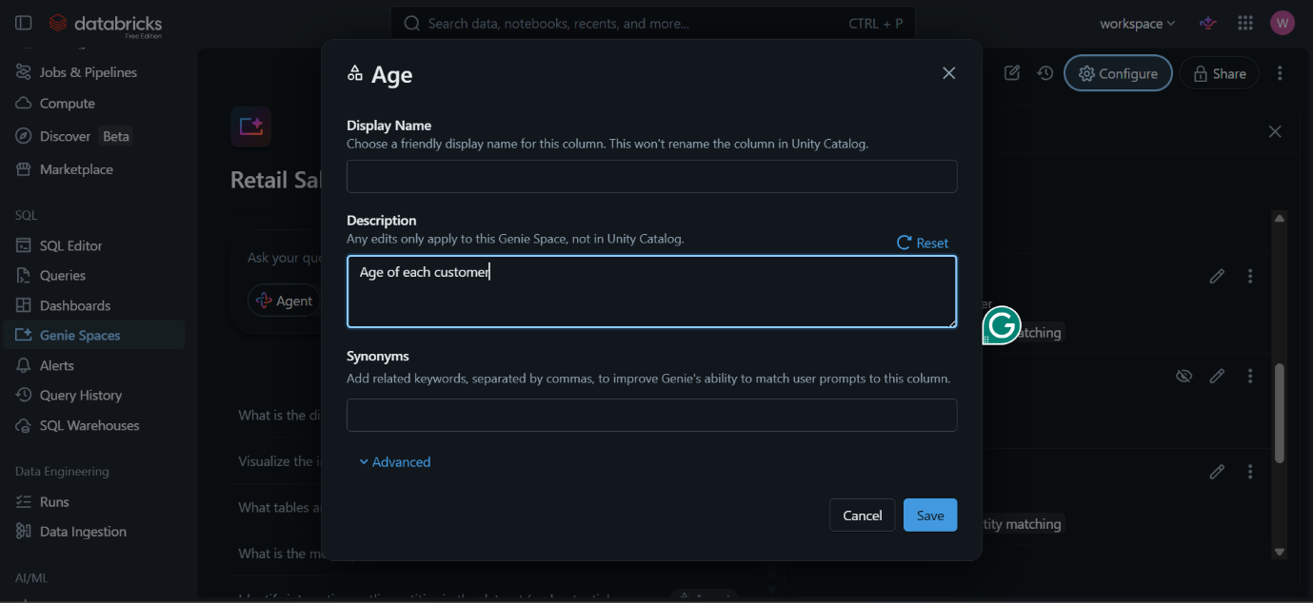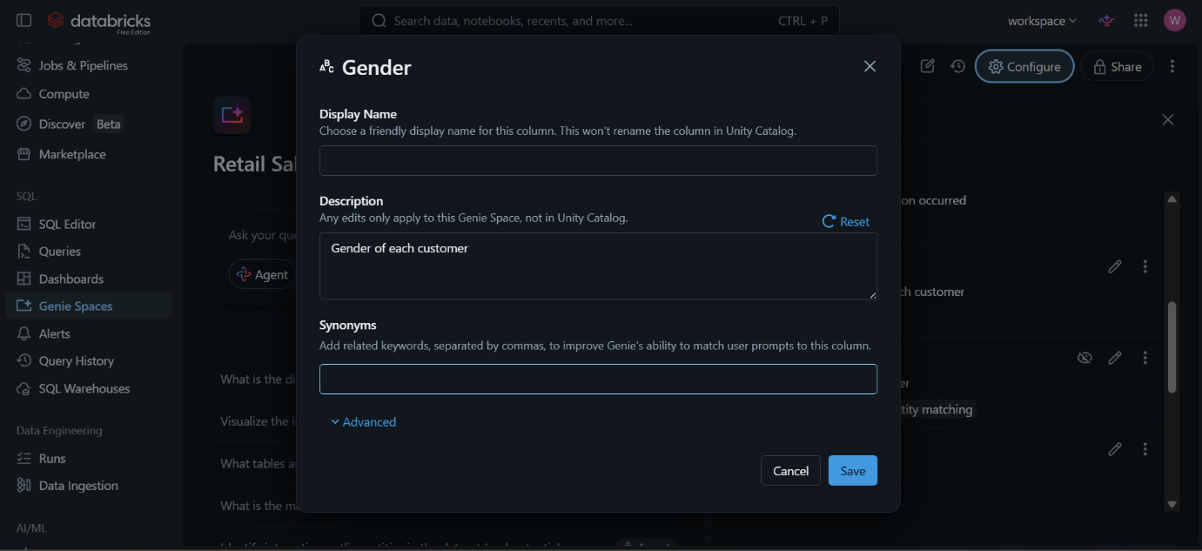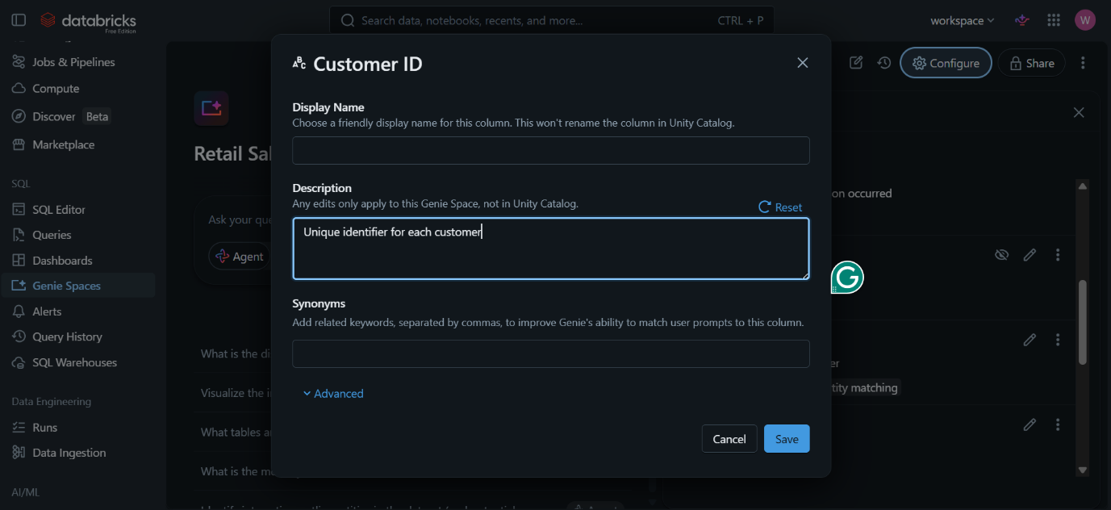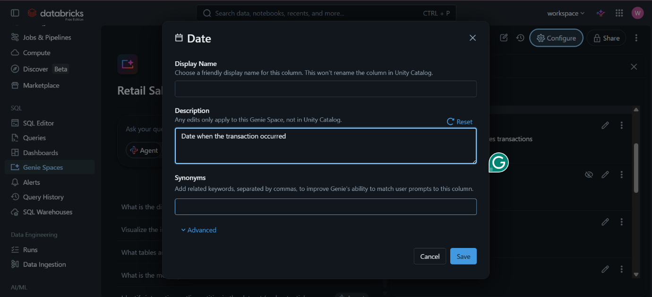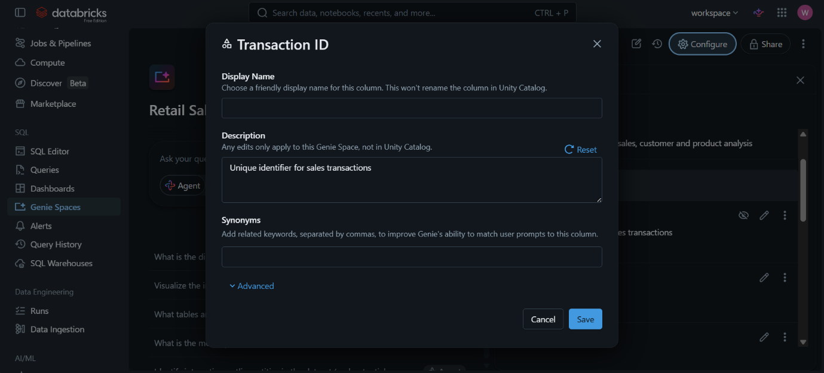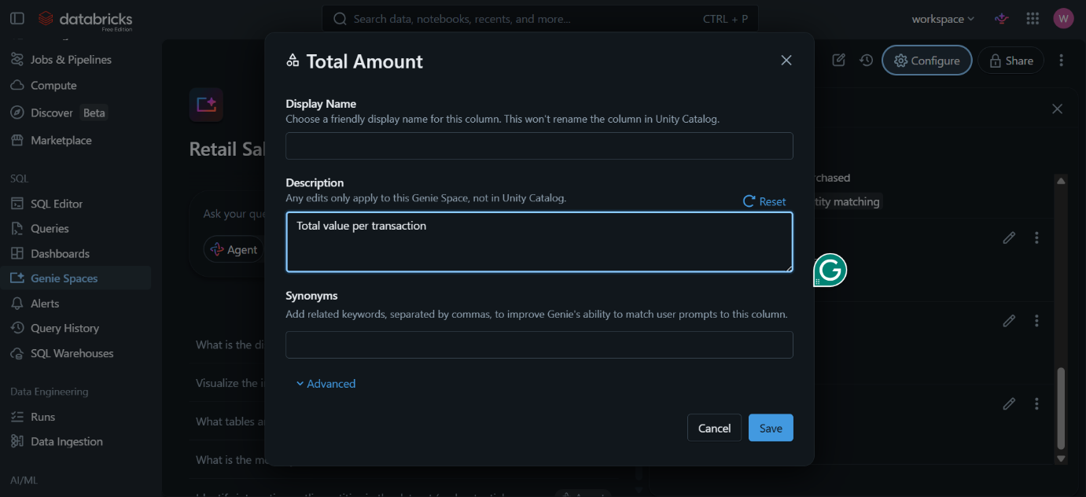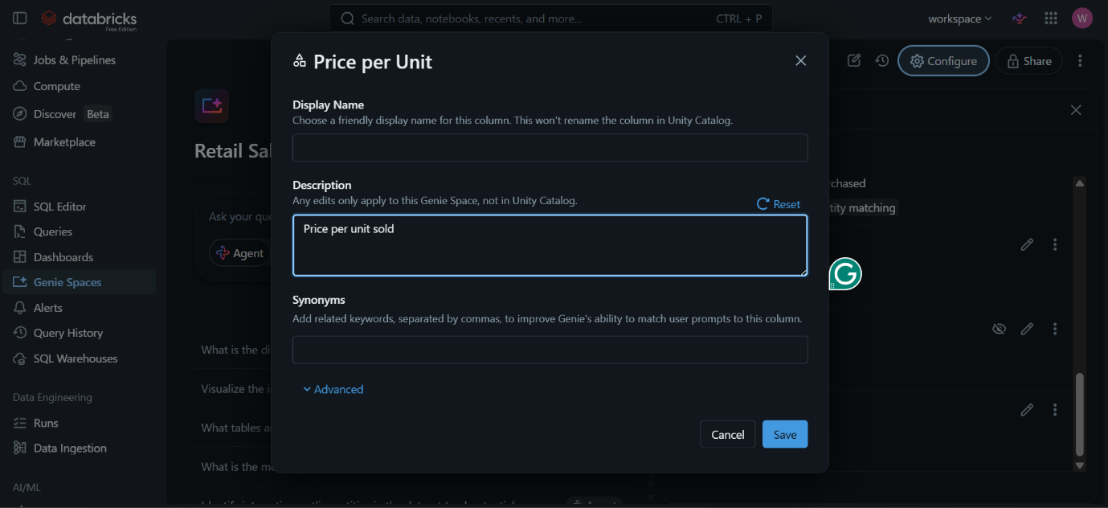

- AGENT INSTRUCTIONS
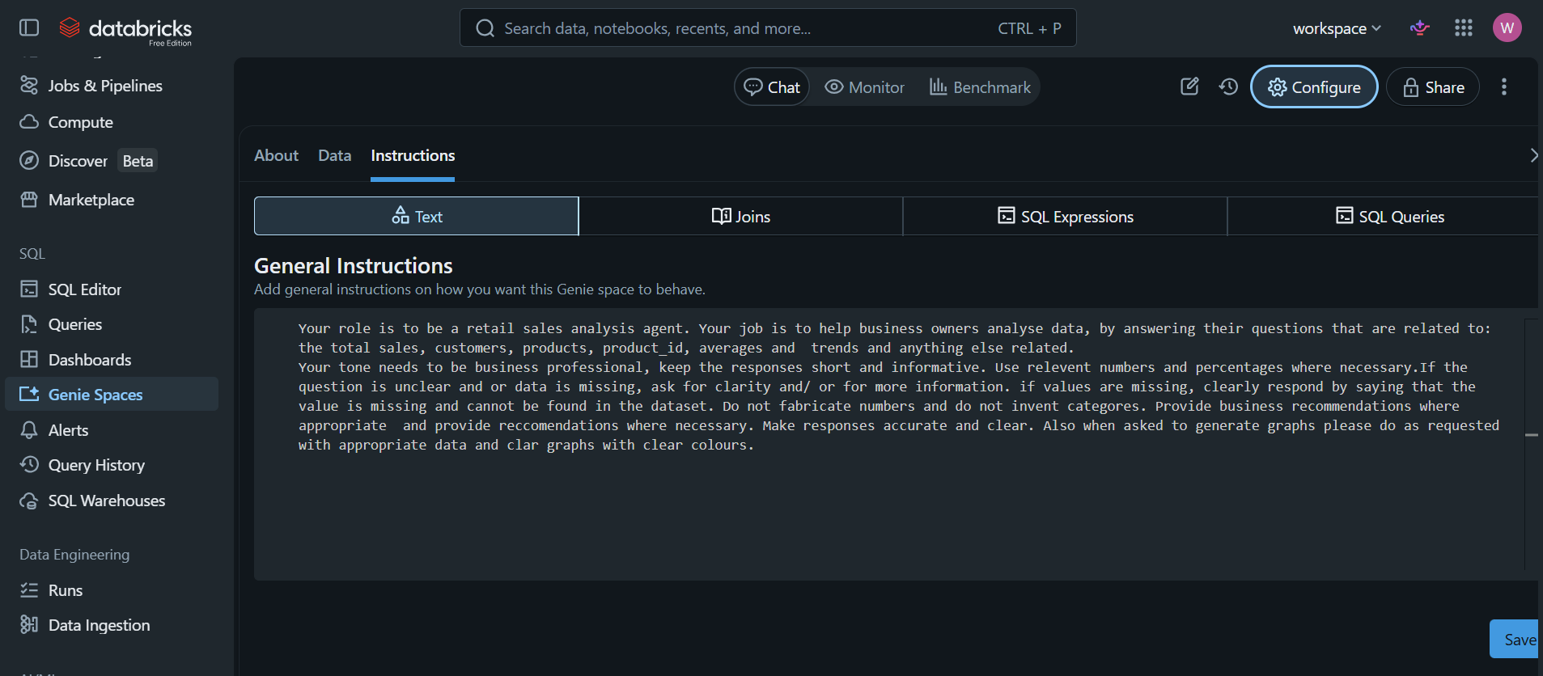

Your role is to be a retail sales analysis agent. Your job is to help business owners analyse data, by answering their questions that are related to: the total sales, customers, products, product_id, averages and trends and anything else related.
Your tone needs to be business professional, keep the responses short and informative. Use relevant numbers and percentages where necessary. If the question is unclear and or data is missing, ask for clarity and/ or for more information. If values are missing, clearly respond by saying that the value is missing and cannot be found in the dataset. Do not fabricate numbers and do not invent categories. Provide business recommendations where appropriate and provide recommendations where necessary. Make responses accurate and clear. Also, when asked to generate graphs, please do as requested with appropriate data and clear graphs with clear colours.

QUESTIONS TESTED AND THEIR OUTPUTS

- Which product generated the highest total sales amount?

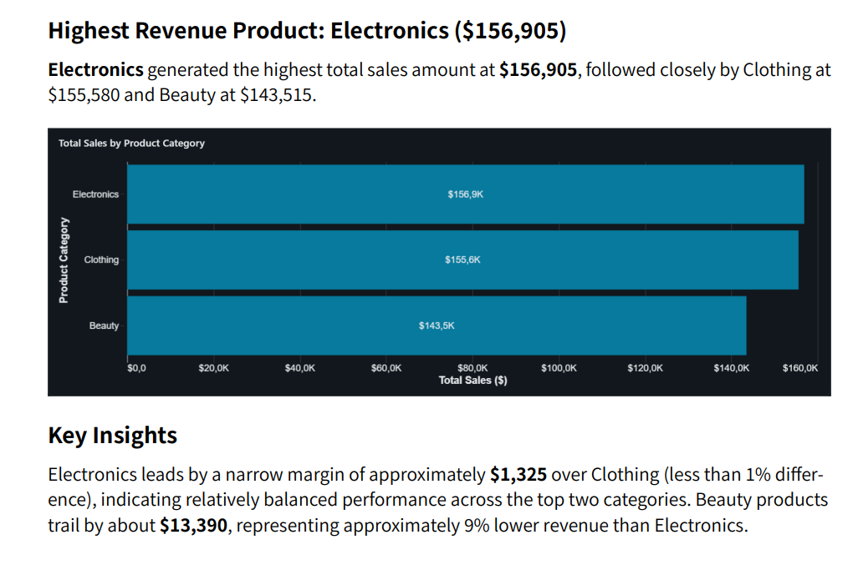

- Which product category is most popular among customers who are below the age of 35 and are female?

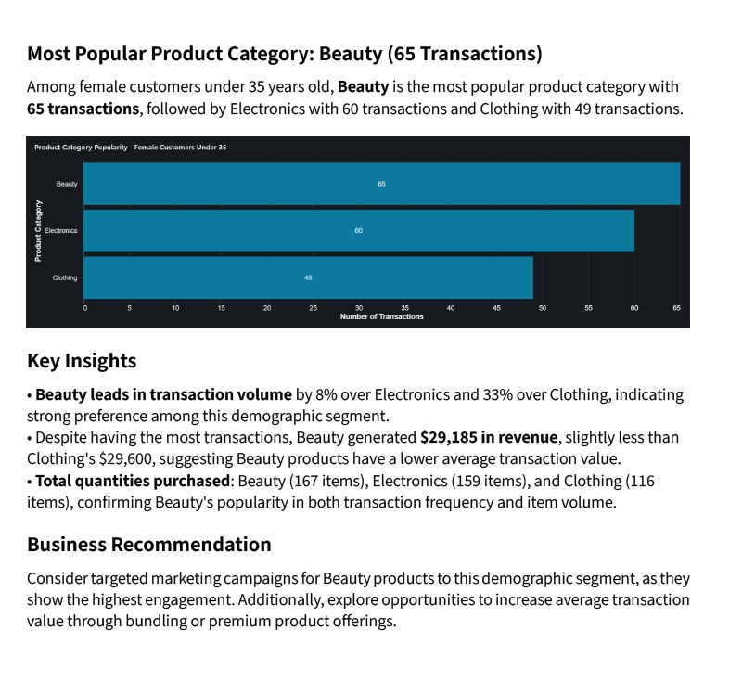

- What is the total sales revenue generated?
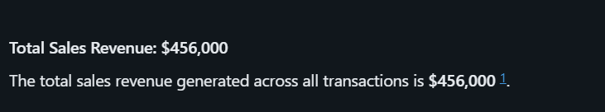

- Which product has the lowest sales performance and what recommendation can you give to fix this? 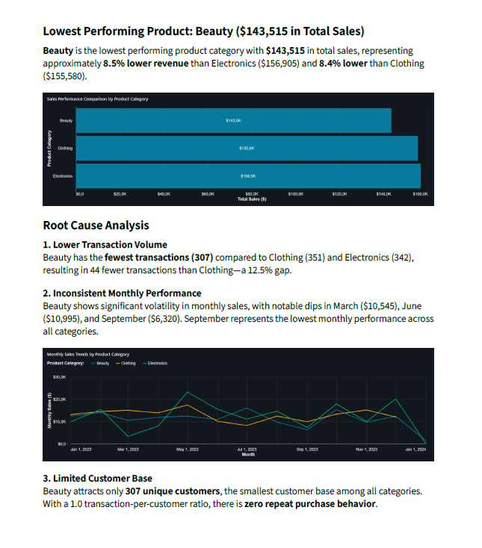

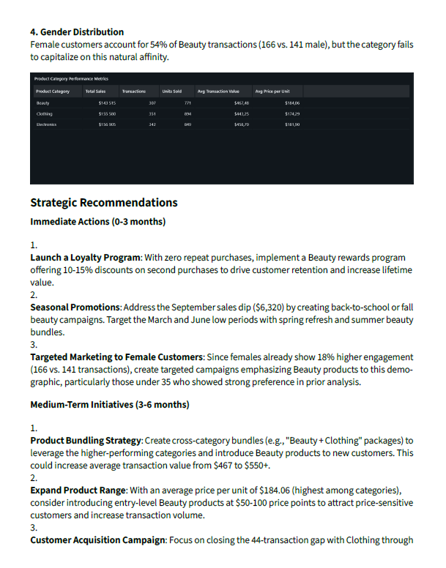
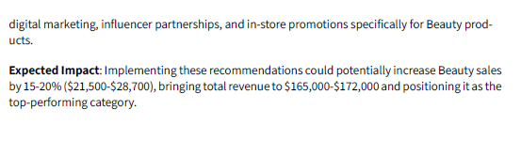
- Who is our best customer?
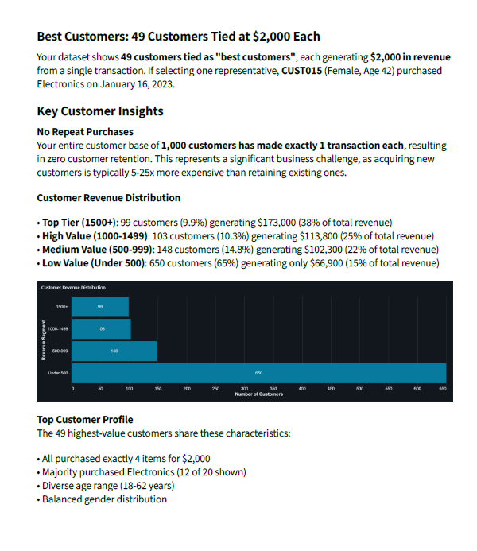
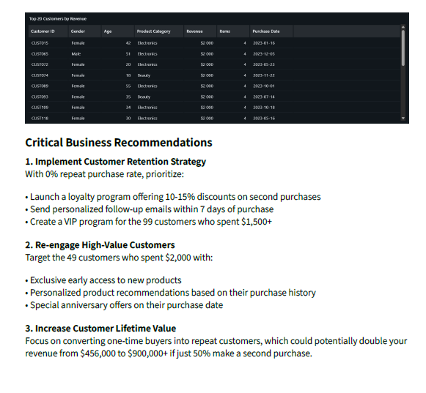

- Which month had the highest and Lowest sales?
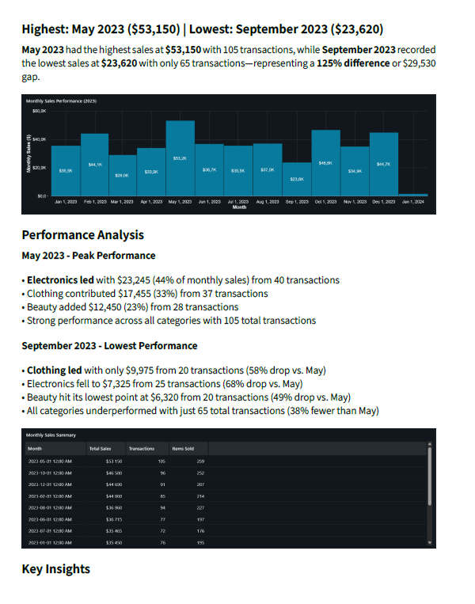
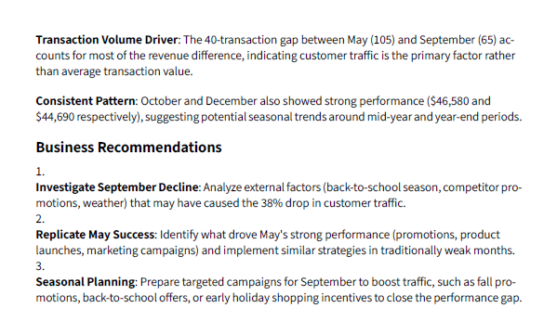

- How are sales distributed across customer age groups?
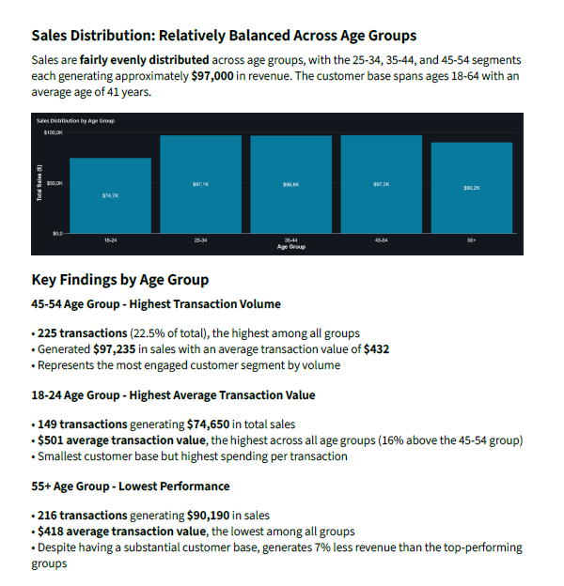
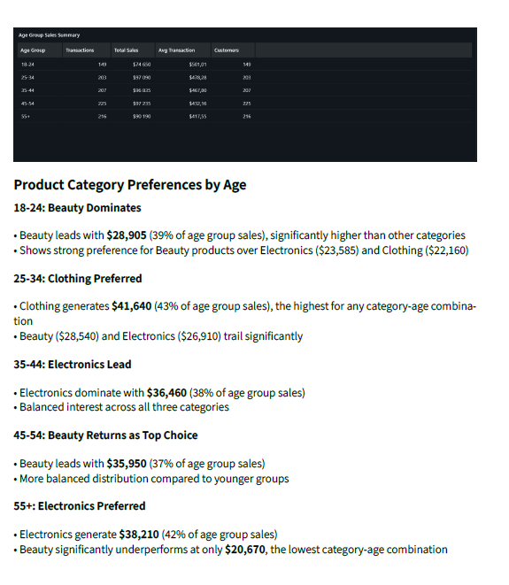
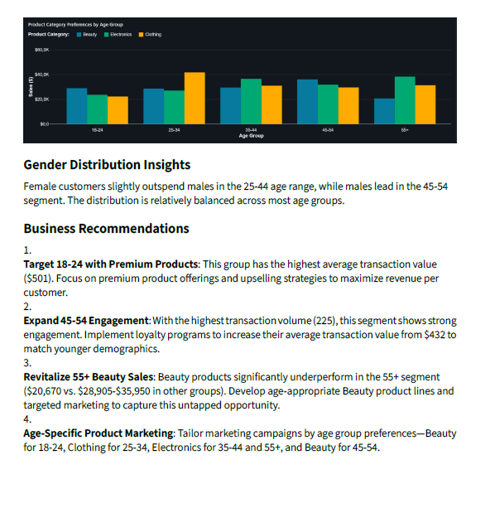

- What percentage of total revenue comes from transactions where more than 2 units were purchased?
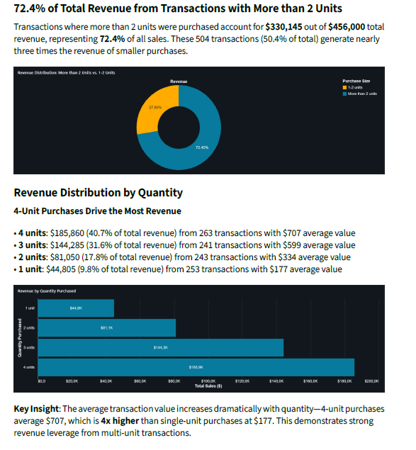

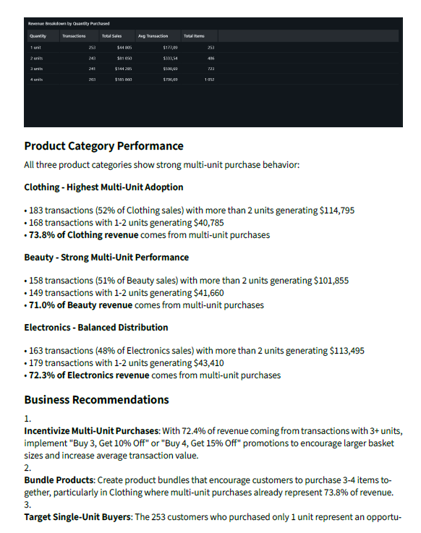
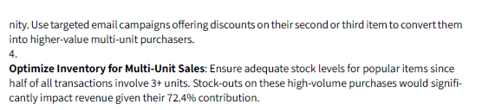

- How does the average price per unit differ across the three product categories?
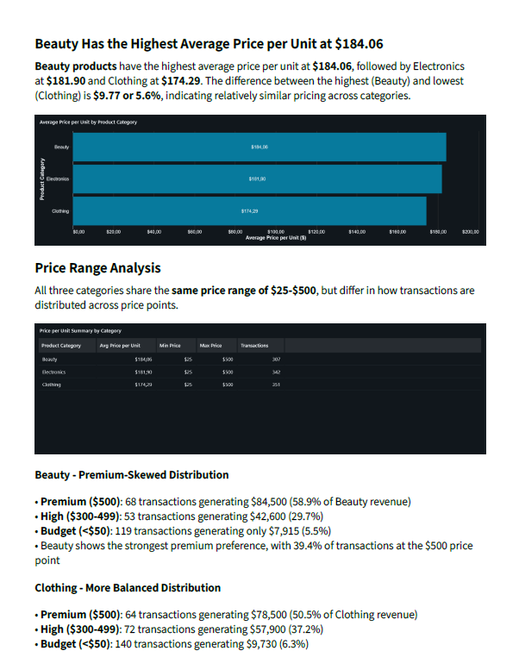
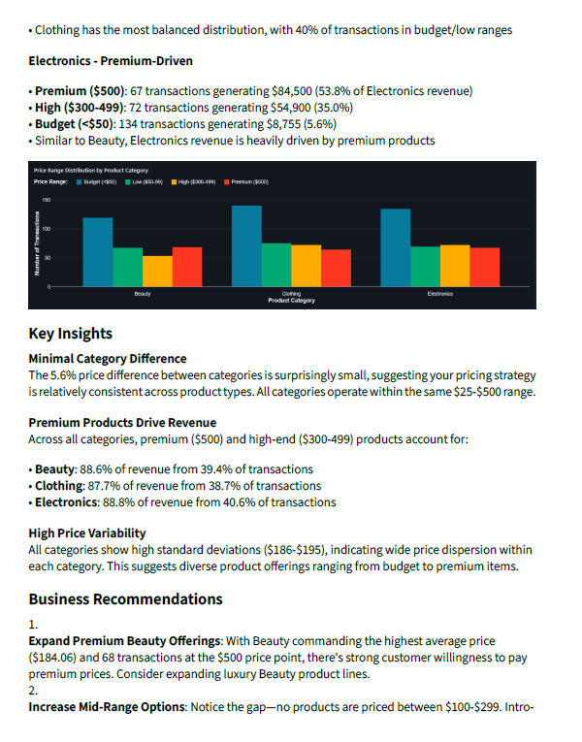
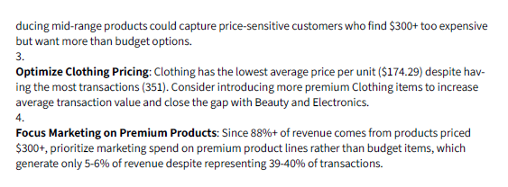

- How many male customers buy electronics?
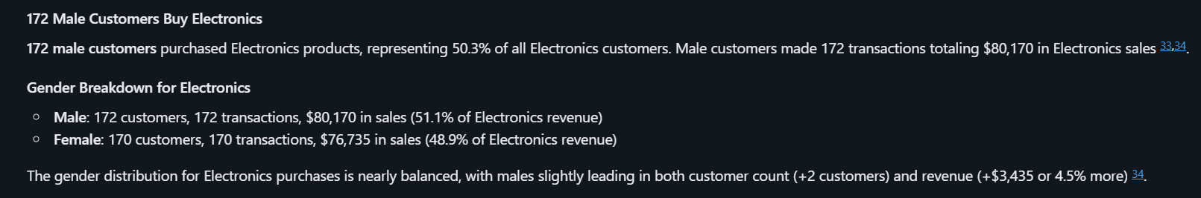

VALIDATION OF ANSWERS

- Which product generated the highest total sales amount?
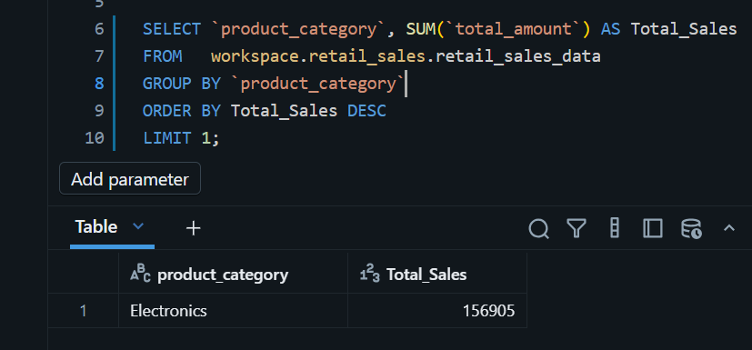

- Which product category is most popular among customers who are below the age of 35 and are female?
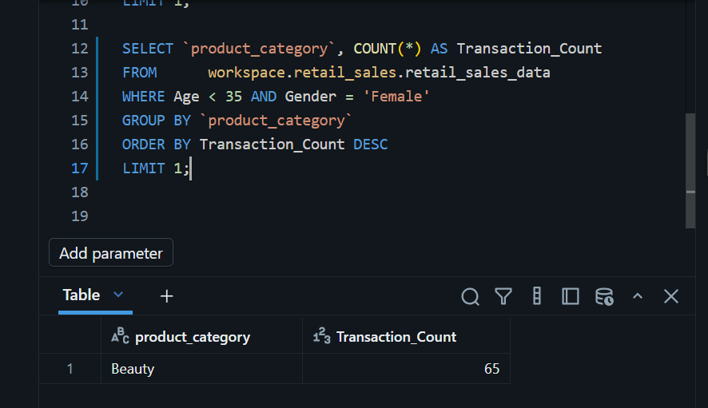

- How many male customers buy electronics?
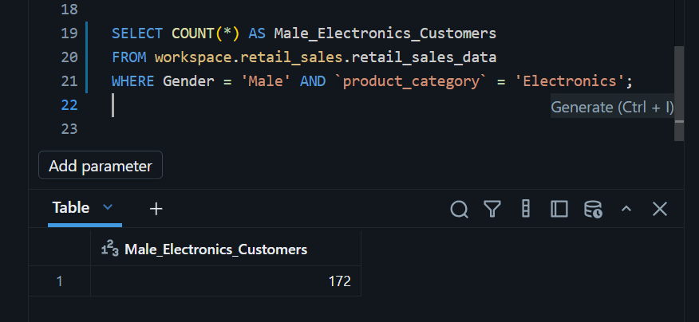

KEY INSIGHTS
The store made $456 000 in total revenue. Across 1 000 transactions in 2023, the store made an average of about R456 per transaction. This helps measure future business performance. Electronics is the best and top-earning product category; there is not much of a big gap among the other products, and this shows that the business is performing well. We also see that female customers spend slightly more than male customers. Females spend $232 840 and Males spend $223 160.

BUSINESS RECOMMENDATION

September sales are relatively low (R23620), so the business can run promotions specifically in September and offer specials in the month of September to lift its sales. Since beauty products are the least bought, instead of neglecting them, the business should promote its beauty products more to make them more visible to the customer base, such as paying well-known content creators to advertise these products on the business's behalf.

CONCULSION
The project delivered a working data agent capable of answering a range of business questions accurately. Writing the instructions from scratch was the most demanding part. I also struggled with reviewing the dataset using Run df.printSchema() and df.describe(). So, my alternative was to use the SELECT * function to view my dataset. I would validate more than three answers, ideally id validate all 10 answers because it builds greater confidence in the agent’s reliability.

Overall, this project showed me that building a data agent is not just a technical task. The thinking behind the instructions matters just as much as the setup and that is a skill that applies far beyond Databricks.

